# Q1: CODE:

**MUHAMMAD HASSAM KHAN**

**SID: 11146**

**COAL LAB 10**

INCLUDE Irvine32.inc

.data

a1 byte "Enter 1st number: ",0 a2 byte "Enter 2nd number: ",0 a3 byte "Enter 3rd number: ",0

num1 dword ? num2 dword ? num3 dword ?

msg byte "Highest number = ",0 largest DWORD ?

.code

main PROC

mov edx, OFFSET a1 call WriteString call ReadInt

mov num1, eax

mov edx, OFFSET a2 call WriteString call ReadInt

mov num2, eax

mov edx, OFFSET a3 call WriteString call ReadInt

mov num3, eax

mov eax,num1 mov largest,eax cmp eax,num2 jge l1

mov eax,num2 mov largest,eax l1:

mov eax,largest cmp eax,num3 jge l2

mov eax,num3 mov largest,eax l2:

mov edx,offset msg call writestring

call writedec call crlf call waitmsg

exit

main ENDP END main

# SCREENSHOT:

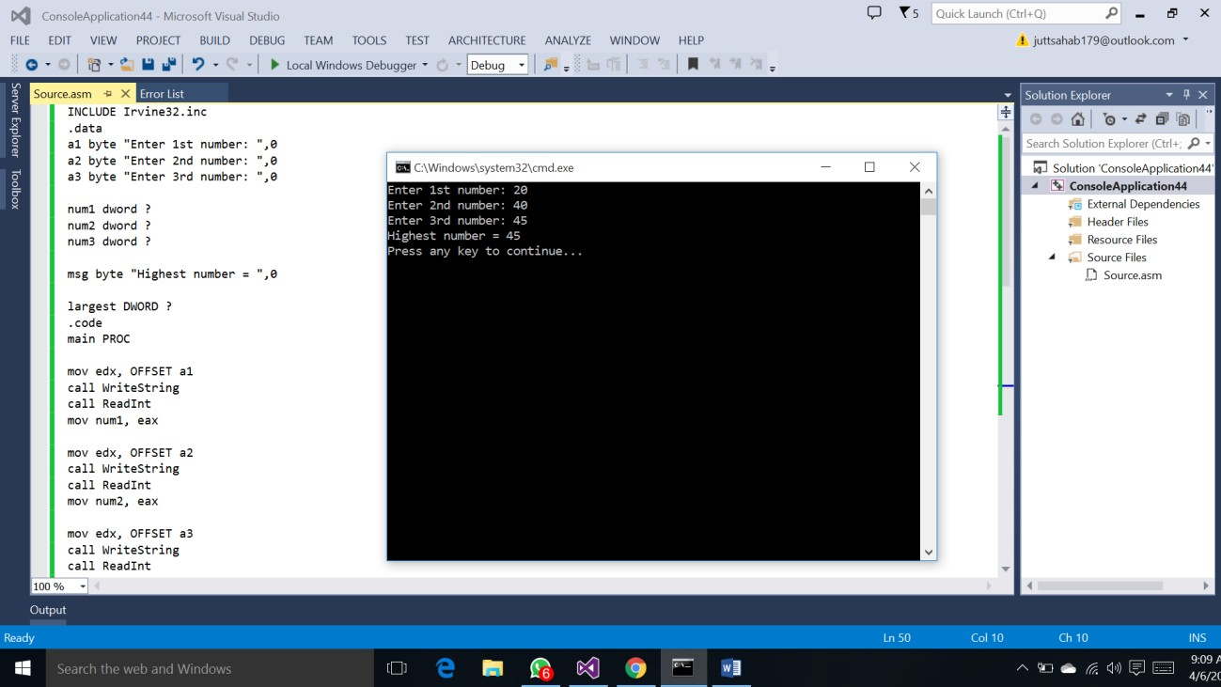

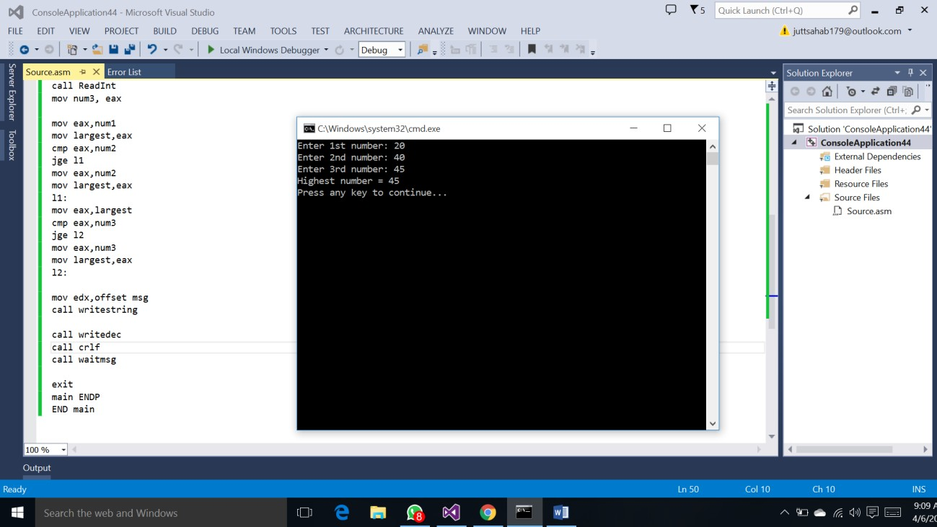

**Q2: CODE:**

INCLUDE Irvine32.inc

.data

array SDWORD -3,-6,-1,-10,10,30,40,4

msg byte "Enter a hexadecimal value for test sign bit: " val word ?

.code

main PROC

mov esi,OFFSET array

mov ecx,LENGTHOF array

mov edx,offset msg call writestring call readhex

mov val,ax

next:

test WORD PTR [esi],ax pushfd

add esi,TYPE array popfd

loopnz next jnz quit

sub esi,TYPE array mov eax,[esi]

call writeint call crlf

quit:

call waitmsg

exit

main ENDP END main

# SCREENSHOT:

